**Assignment No:-7**

Name:-Suryawanshi Sangramsingh Sambhaji

Batch: - Delta - DCA (Java) 2024 Date:-8/5/2024

**1. Write a Java program that prints all palindrome numbers between 1 and n.**

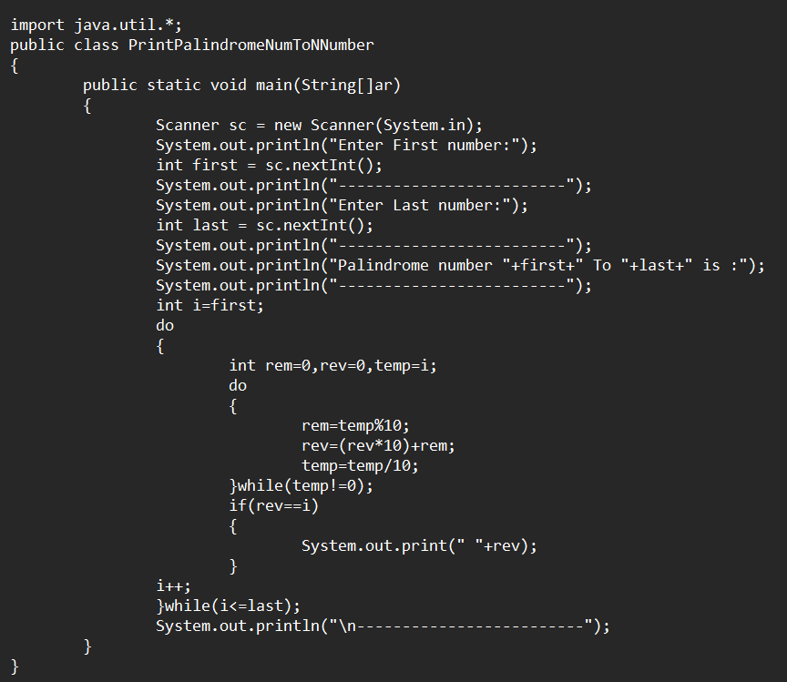

**Output:**

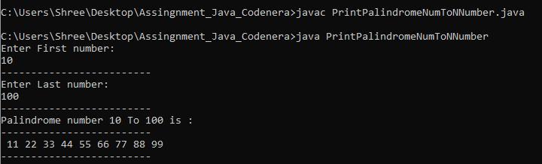

**2. Develop a Java program to print all Armstrong numbers in the range from user.**

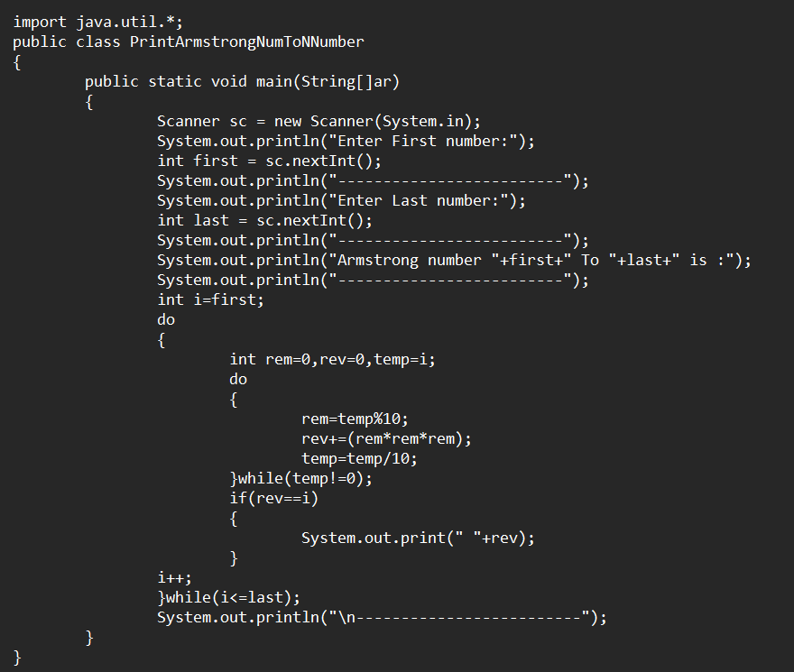

**Output:**

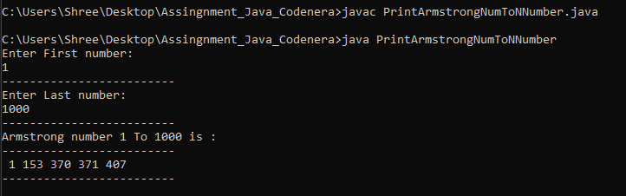

**3.** **Create a Java program to print all prime numbers between 10 and n.**

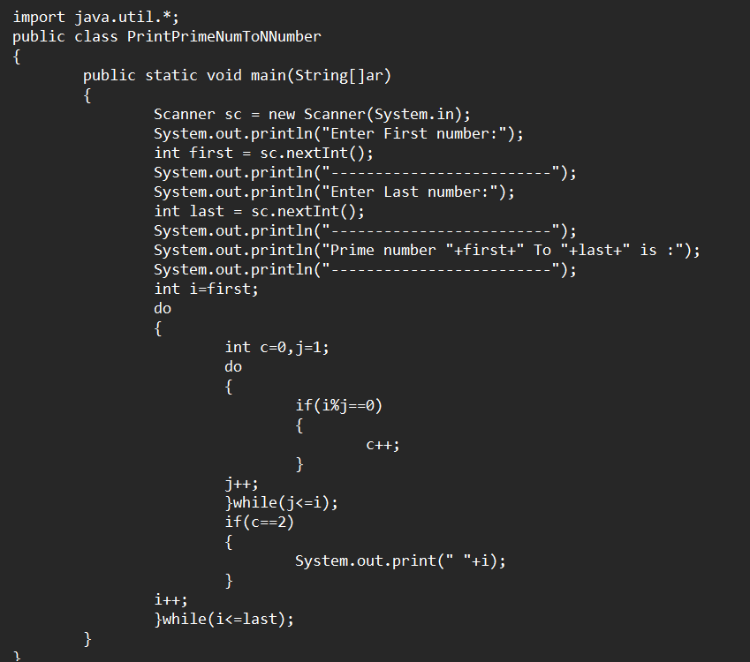

**Output:**

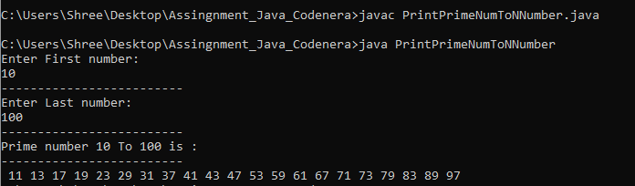

**4. Write a Java program that takes a number as input from the user and prints its reverse.**

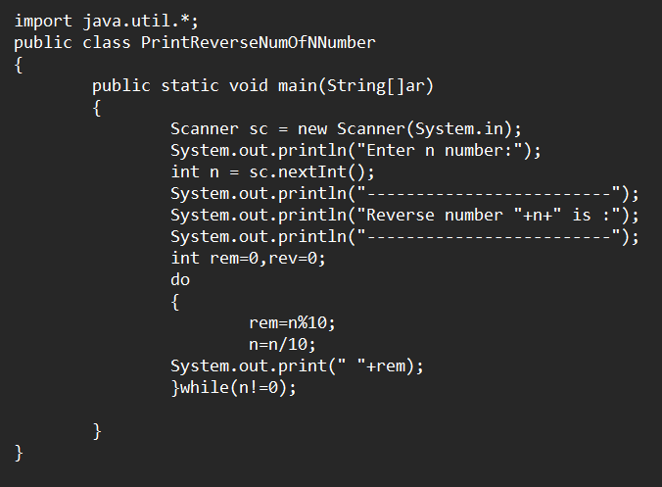 **Output:**

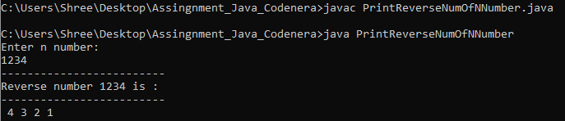

**5. Implement a Java program that takes a 5-digit number from the user. Search for a specific number within it, and if found, print its count.**

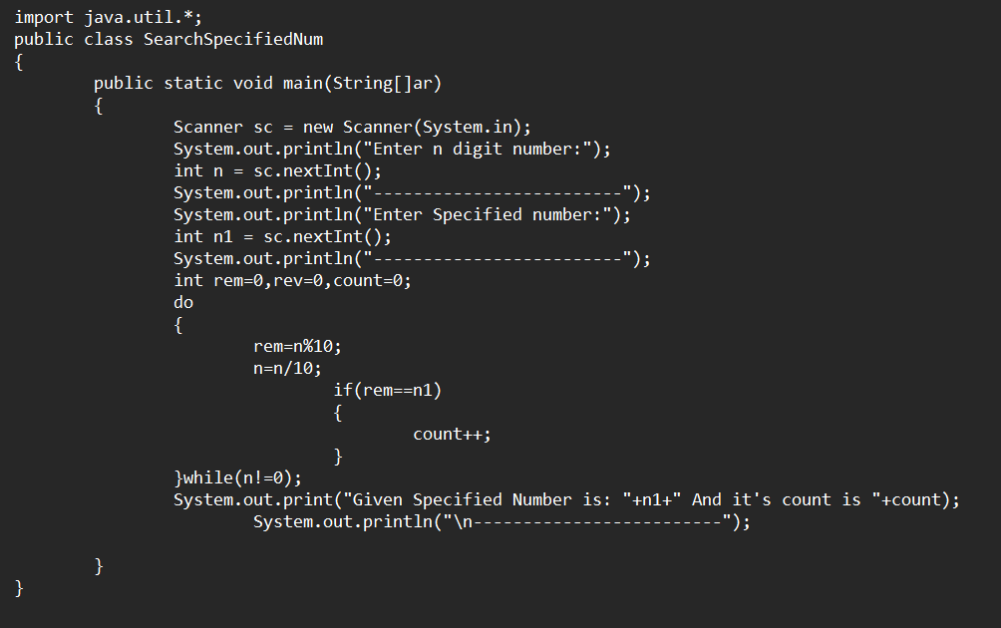 **Output:**

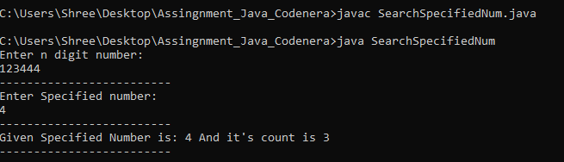

**6.** **Write a Java program that takes a number from the user and prints the Fibonacci series up to that number.**

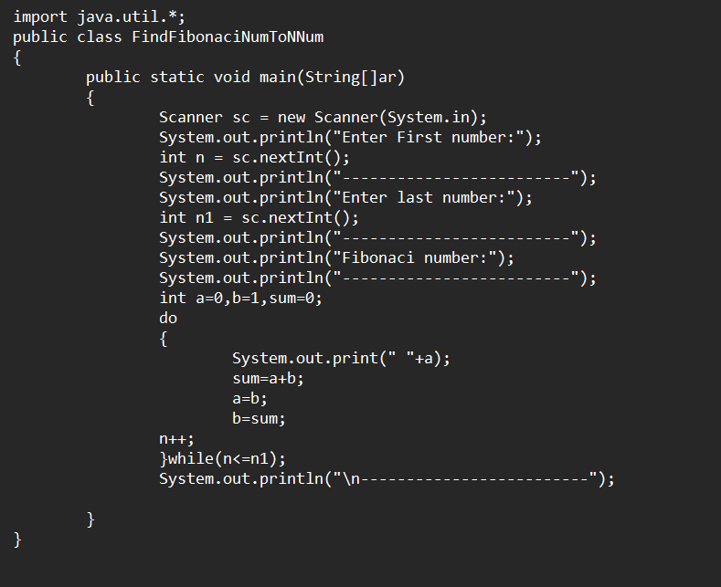

**Output:**

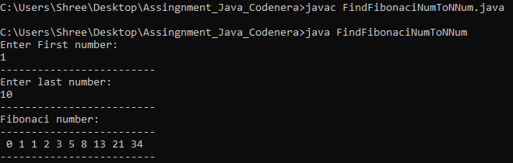

**7. Write a program to input basic salary of an employee and calculate its Gross salary according to following:**

**Basic Salary <= 10000: HRA = 20%, DA = 80%**

**Basic Salary <= 20000: HRA = 25%, DA = 90%**

**Basic Salary > 20000: HRA = 30%, DA = 95%.**

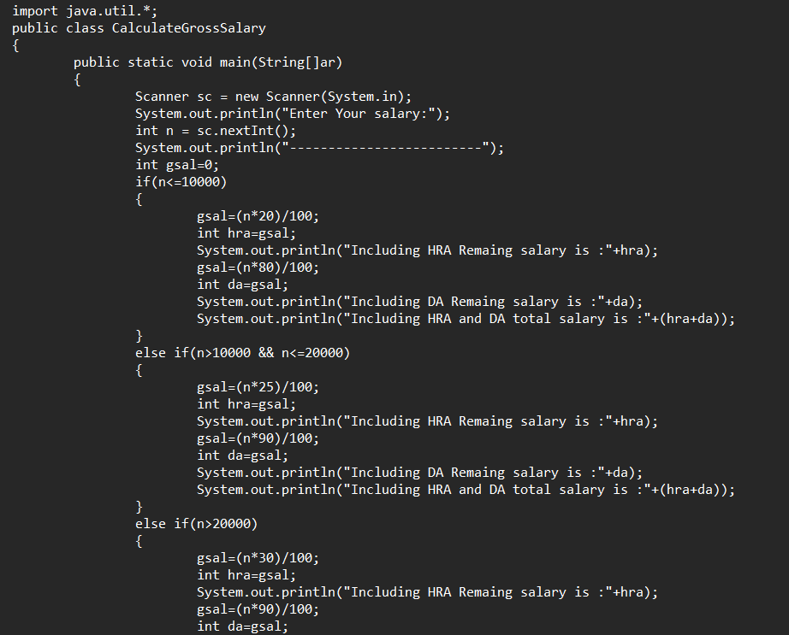 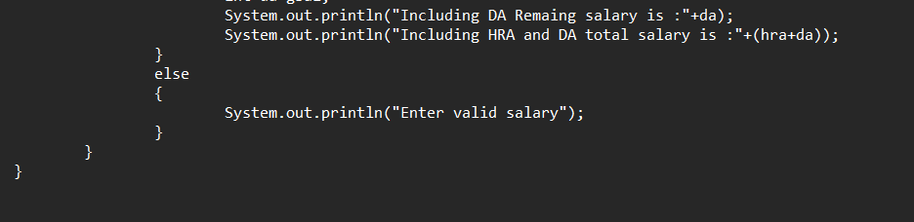

**Output:**

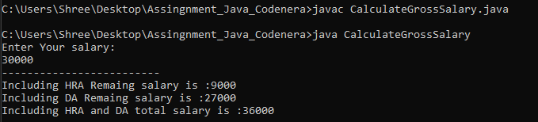

**8. Write a program to input electricity unit charges and calculate total electricity bill according to the given condition:**

**For first 50 units Rs. 0.50/unit**

**For next 150 units Rs. 0.75/unit**

**For next 250 units Rs. 1.20/unit**

**For unit above 250 Rs. 1.50/unit an additional surcharge of 20% is added to the bill** 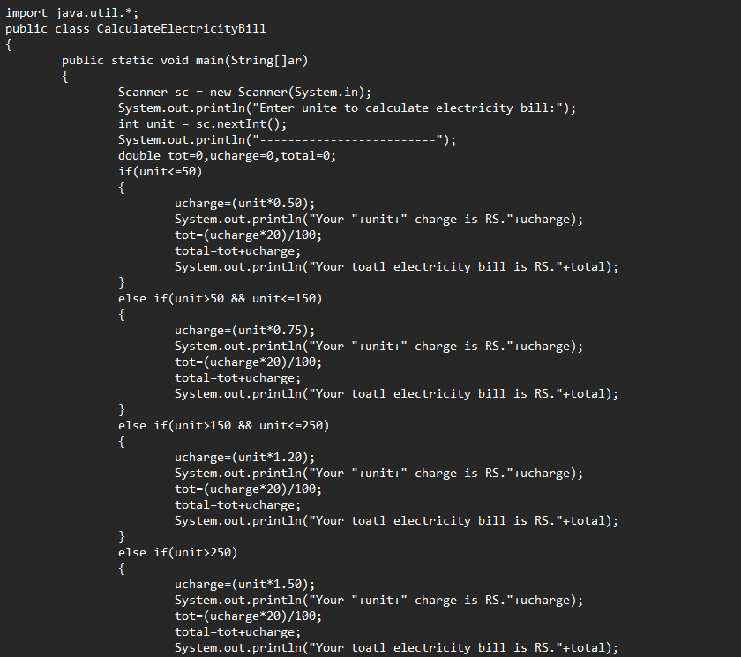 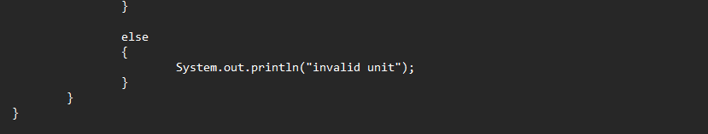

**Output:**

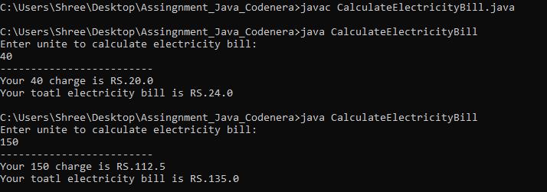

**9. Write a java program that will check for the following conditions:**

**If the light is green – Car is allowed to go**

**If the light is yellow – Car has to wait**

**If the light is red – Car has to stop**

**Other signal – unrecognized signal. Example black, blue, etc.**

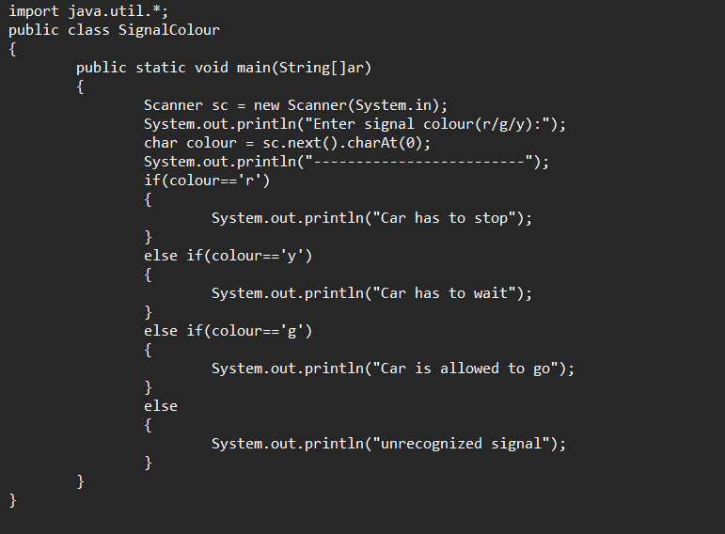

**Output:**

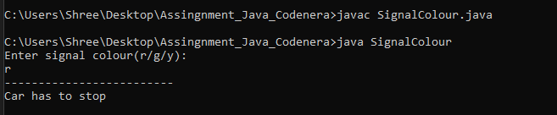

**10. The current year and the year in which the employee joined the organization are entered through the keyboard. If the number of years for which the employee has served the organization is greater than 3 then a bonus of Rs. 2500/- is given to the employee. If the years of service are not greater than 3, then the program should do nothing.**

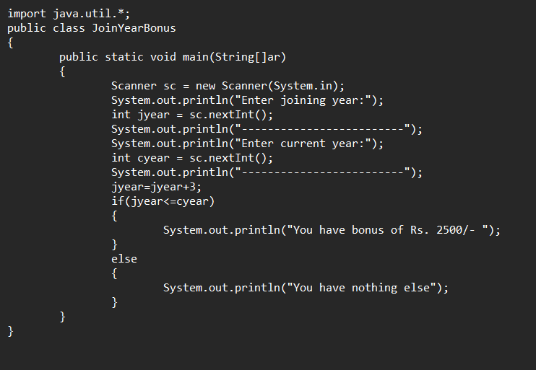

**Output:**

